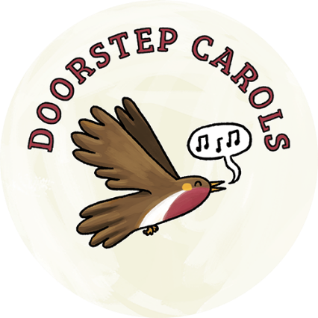
Doorstep Carols Suffolk 2022
Information for Street Organisers
www.lightwave.community/doorstep-carols

How to become a street organiser
All you need to do is
1. Ask some neighbours if they would like to sing along with you
2. Give them a copy of the words downloadable from www.lightwave.community/doorstep-carols
3. Go and sing on your doorstep along with your neighbours on theirs on 14th Dec at 6pm
If you want to, you can play music yourselves, raise money for charity, shake sleigh bells or add other Christmassy details - dress like an angel or have Father Christmas walk past. Have lots of fun. We'd love to see what you are doing - register on the webpage above and post your ideas and preparations on the “Doorstep Carols Suffolk” facebook page.

Radio Suffolk Programme
There are 16 songs to sing on the carol sheet. Radio Suffolk plan to use all 16 in order. They are thinking of 3 bursts of singing, around 13-14 minutes each. In the breaks, people can make themselves a hot chocolate, wave to neighbours etc.
You could arrange for something particular to your street in these gaps if you like. If you register your participation at www.lightwave.community/doorstep-carols, the Lightwave team will let you know of any changes to this schedule. You can also let us know if you would like radio Suffolk to phone into your street – and tell Suffolk what you are doing on the night. Afterwards, the programme from the 14th will be on BBC sounds to listen again to whenever people like
If you would like to know more, do get in contact
The Lightwave Team
Lightwave.community@cofesuffolk.org

